Project Design Phase-II
Technology Stack (Architecture & Stack)

Date | 13 July 2026
Team ID
Project Name | Visualizing Housing Market Trends: An Analysis of Sale Prices and Features using Tableau
Maximum Marks | 4 Marks
Technical Architecture:
The deliverable includes the architectural diagram below along with the information in Table-1 and Table-2.
Visualizing Housing Market Trends — Architecture Flow

Guidelines:
• Include all the processes (as an application logic / technology block)
• Provide infrastructural demarcation (Local / Cloud)
• Indicate external interfaces (third-party APIs etc.)
• Indicate Data Storage components / services
• Indicate interface to machine learning models (if applicable)
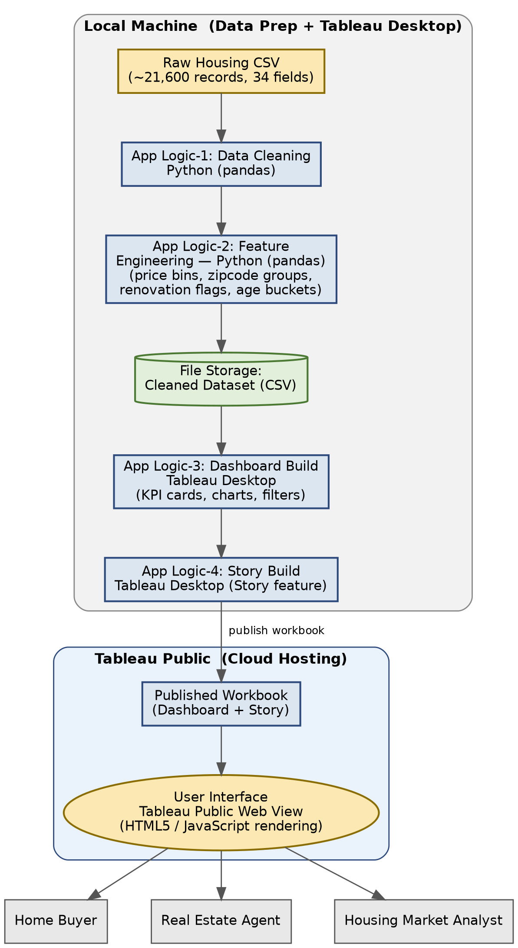

Table-1: Components & Technologies

S.No | Component | Description | Technology
1 | User Interface | How users view housing market insights, directly through the published Tableau Public dashboard and story in a web browser | Tableau Public (Web-based Interactive View), HTML5 / JavaScript (Tableau rendering)
2 | Application Logic-1 | Cleans and prepares the raw housing CSV dataset prior to visualization (handling missing values, formatting fields, etc.) | Python (pandas)
3 | Application Logic-2 | Transforms prepared data into engineered features used by the dashboard (sale-price bins, zipcode grouping, renovation flags, age buckets) | Python (pandas)
4 | Application Logic-3 | Builds the interactive KPI cards, charts and filters that make up the housing dashboard | Tableau Desktop
5 | Application Logic-4 | Builds the guided Tableau Story narrating key housing-market insights | Tableau Desktop (Story feature)
6 | Database | This project does not use a traditional database; data is sourced directly from a CSV file | Not Applicable for this project
7 | Cloud Database | Not Applicable for this project | Not Applicable for this project
8 | File Storage | Storage of the raw and cleaned/transformed housing dataset used to build the dashboard | Local File System (CSV)
9 | External API-1 | Not Applicable for this project | Not Applicable for this project
10 | External API-2 | Not Applicable for this project | Not Applicable for this project
11 | Machine Learning Model | Not used in the current scope; predictive price modelling was identified as future scope during idea prioritization | Not Applicable for this project
12 | Infrastructure (Server / Cloud) | Application Deployment: dashboard and story published directly to Tableau Public (no dedicated server or custom website); local system used for data cleaning and Tableau Desktop workbook development | Local Machine (Data Prep + Tableau Desktop), Tableau Public (Dashboard & Story Hosting)
Table-2: Application Characteristics
S.No | Characteristics | Description | Technology
1 | Open-Source Frameworks | Open-source Python libraries used for data cleaning and feature preparation | pandas, NumPy
2 | Security Implementations | Public Tableau dashboard exposes only aggregated, anonymised property features; no personally identifiable buyer or seller information is published | Tableau Public access settings
3 | Scalable Architecture | Additional worksheets, dashboards, or datasets can be added to the Tableau Public workbook without restructuring the overall project | Modular Tableau workbook structure
4 | Availability | Dashboard and story remain accessible anytime via the Tableau Public link, with no dependency on a dedicated hosting server | Tableau Public hosting
5 | Performance | Optimised visualisations using pre-aggregated fields (sale-price bins, zipcode groups) and filtered extracts for fast load and filter response | Tableau Public rendering optimisation
References
https://c4model.com/
https://developer.ibm.com/patterns/online-order-processing-system-during-pandemic/
https://www.ibm.com/cloud/architecture
https://aws.amazon.com/architecture
https://medium.com/the-internal-startup/how-to-draw-useful-technical-architecture-diagrams-2d20c9fda90d

